**Moderate to Severe Evaluation**

Sample_id : **CH9NKU(Dog)**

Link: https://app.animalbiome.com/pet/assessment/report/3b0c3d23-77c5-4a20-940b-10bb46ee3bc7

Cats and dogs:

Any two of the following:

(

High Red Flag Megamonas OR (failed)

High Red Flag Sutterella OR (failed)

High Red Flag Collinsella OR (failed)

Low Red Flag Bacteroides OR (failed)

Low Red Flag Blautia (failed)

);

OR

Dogs:

8 or more yellow flags (**passed**) 8

OR 8 or more red flags (**passed**)8

High red megamonas,suttrella and collinsella failed.

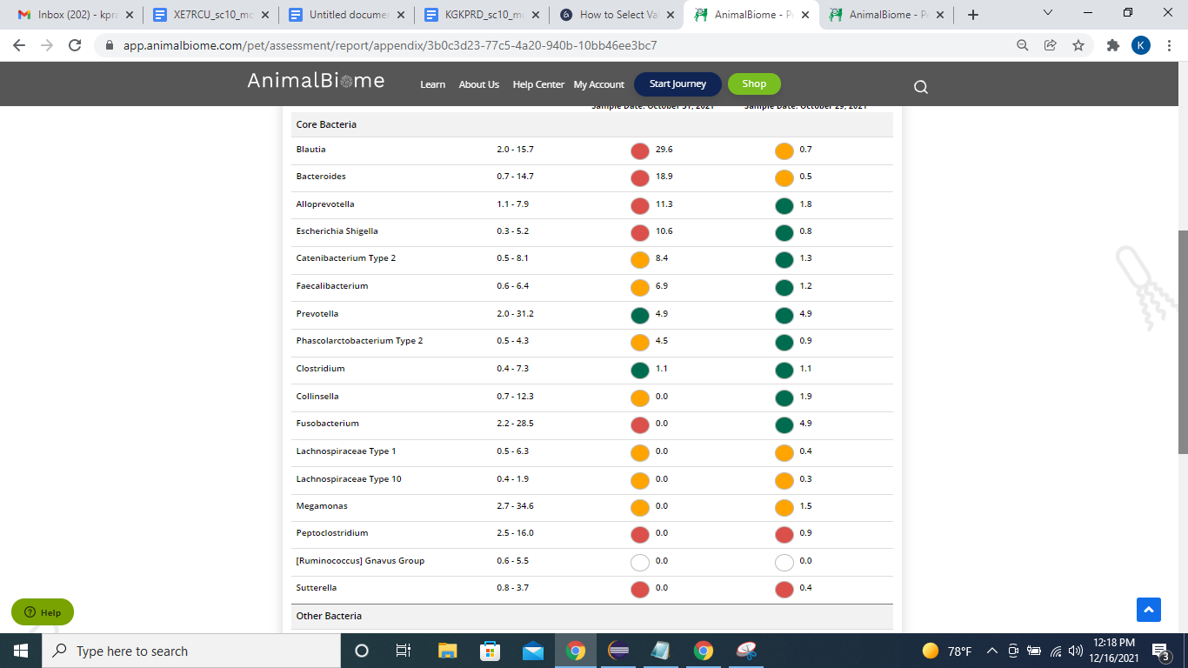

**Low group evaluation:**

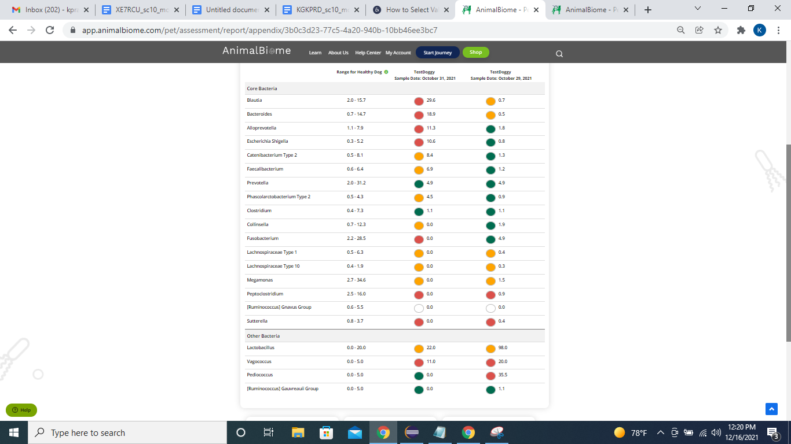

low red blautia : failed**.**

Low red bacteroides :failed (all conditions failed ) in the primary group.

Total yellow flags : 8

Red flags : 8

The result : **False True True**

Moderate to severe results:Pass

Expected result :  **Moderate to severe**

Achieved result : **passed.**

